**Hierarchies in PBI:**

1) Implicitly created by PBI -- For **date** column (Resusable for ALL the visual)

2) Explicitly created by user:

2.1) Hierarchy created within a visual. (So, it will be specific to that visual)

2.2) Hierarchy created within a Dimension. (Resusable for ALL the visual)

1. After importing data from the Excel file, the original columns will be as shown next 🡪

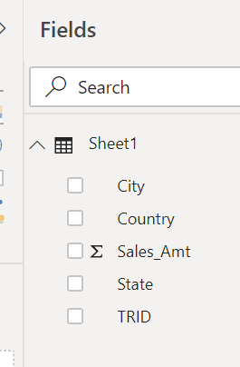

1. To create a hierarchy or to add a column to an existing hierarchy right click on that particular column and select the relevant option.
   1. R.C. on Country column and select new Hierarchy

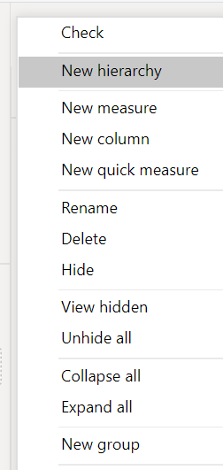

* 1. Country Hierarchy gets created as shown next

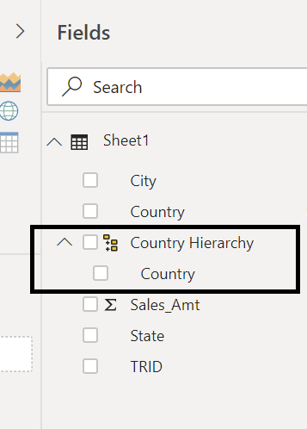

* 1. Now R.C. on State and through Add to Hierarchy select Country Hierarchy as shown next

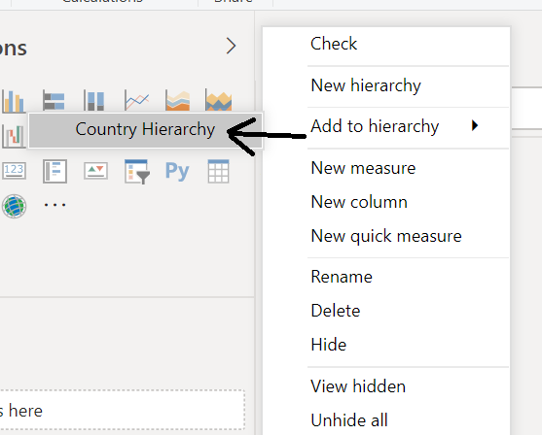

* 1. Repeat the same steps b & c for City column
  2. Finally, the Country Hierarchy will have the following look:

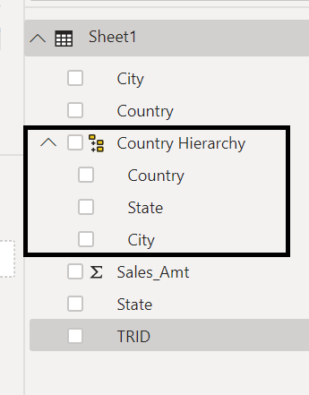

* 1. In Report, add this hierarchy in a bar chart & you will be able to get the drill down ability!!!